LABORATORY OF LANDSCAPE ECOLOGY

The laboratory of Landscape ecology was established as a unit in the Geography Department of the National Institute of Geophysics, Geodesy and Geography at the Bulgarian academy of sciences (BAS), under the Physical Geography Section, with the aim of supporting scientific research on processes in the landscapes and their spatio-temporal changes, performing evaluation of the quality of the natural environment, ecosystem/landscape services and natural capital. An important task of the laboratory is to support the personnel development of scientists in the "Physical Geography" section and to promote the development of young researchers in the field of physical geography.
The laboratory of Landscape ecology consists of two departments: "Soils" headed by Assoc. Prof. Dr. Tsvetan Kotsev and "Waters" headed by Prof. Dr. Georgi Zhelezov. The laboratory's scientific team includes Assoc. Prof. Dr. Velimira Stoyanova, Assoc. Prof. Dr. Kristina Gratsianova, Assoc. Prof. Dr. Marian Varbanov and Assist. Prof. Dr. Zvezdelina Marcheva.
The scientific-research equipment and the acquired analytical methods allow field sampling of soils, surface and underground waters, as well as the determination of hydrological indicators. The available equipment enables the determination of basic physicochemical parameters of water and soil and photometric measurement of concentrations of a number of chemical substances and elements in aqueous solutions. The laboratory has a system for monitoring the quality of river and groundwater in the valley of the Ogosta river in its upper reaches. It includes 23 tube wells and several points on the main river. Some of them are equipped with an automatic telemetry system for measuring and transmitting the information to a remote server, with access to the data through a specialized web portal.
The part of the research work on the projects ROBUHAZ-DUN funded by the European program for cross-border cooperation Bulgaria-Romania (2012-2013), ASCOR (2012-2016) funded by the Bulgarian-Swiss program "Research" (2011-2016), ARSENT (2016-2020) and TOPOMET (2018-2022) funded by the Bulgarian Research Fund was implemented in the laboratory.
The laboratory of Landscape ecology is a real platform for integration and cooperation with other departments and units in the National Institute of Geophysics, Geodesy and Geography, institutes and centers of Bulgarian Academy of Sciences and other institutions. The most intense are these connections with the Institute of Geology (BAS), the Institute of Oceanology "Fridtjof Nansen" (BAS), the Institute of Soil Science, Agrotechnology and Plant Protection "Nikola Pushkarov" at the Agriculture academy, etc. Within the laboratory, intensive work is also carried out with student interns and doctoral students from various higher education institutions - mainly from the "Geography" specialty of Sofia University "St. Kliment Ohridski", University of architecture, civil engineering and geodesy (specialty "Landscape Architecture"), Forestry University (specialty "Ecology"), University of Mining and Geology (specialty "Ecology and Environmental Protection"), etc.
International contacts and cooperation of the laboratory of Landscape ecology related with realization of the joint projects are with established centers in the world scientific community such as ETH Zurich, University of Vienna, Institute of Geography of the Romanian Academy, Institute of Landscape Ecology of the Slovak Academy of Sciences, etc.

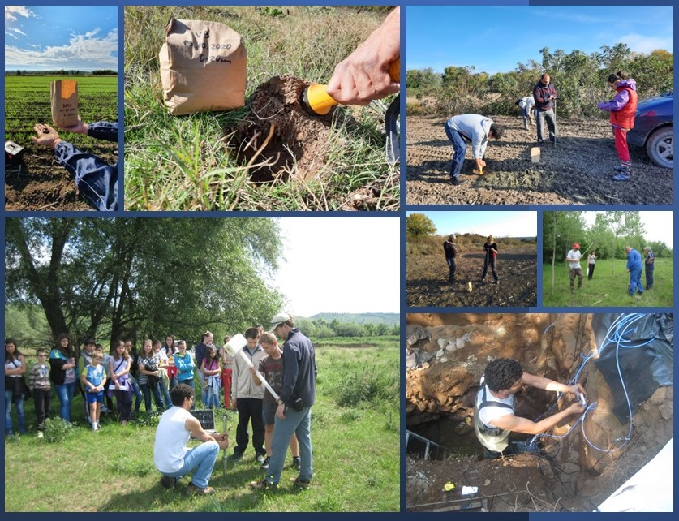
Field work and analysis of soil samples

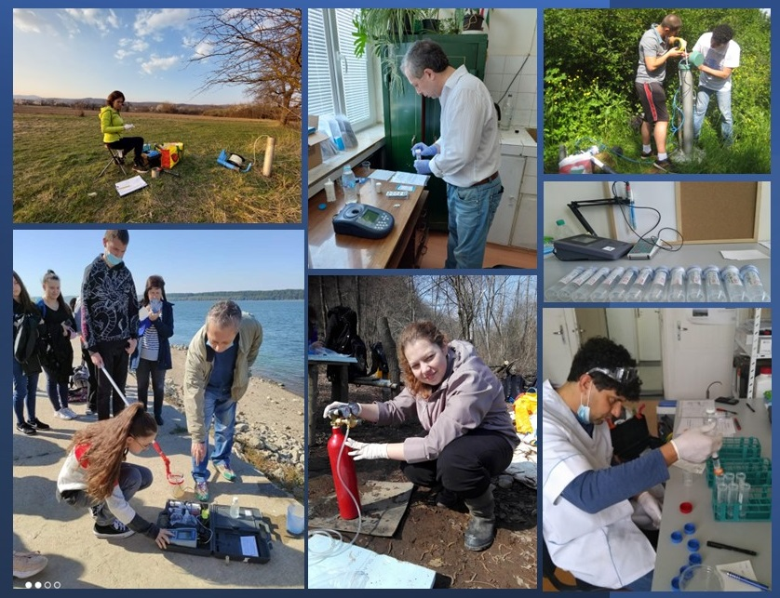
Field and laboratory analysis of water samples

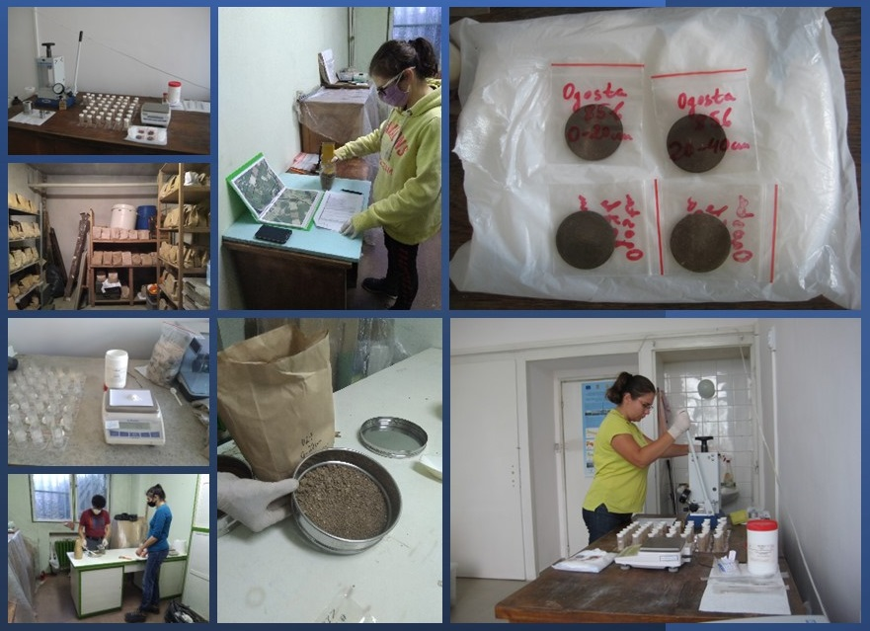
Laboratory analysis of soil samples

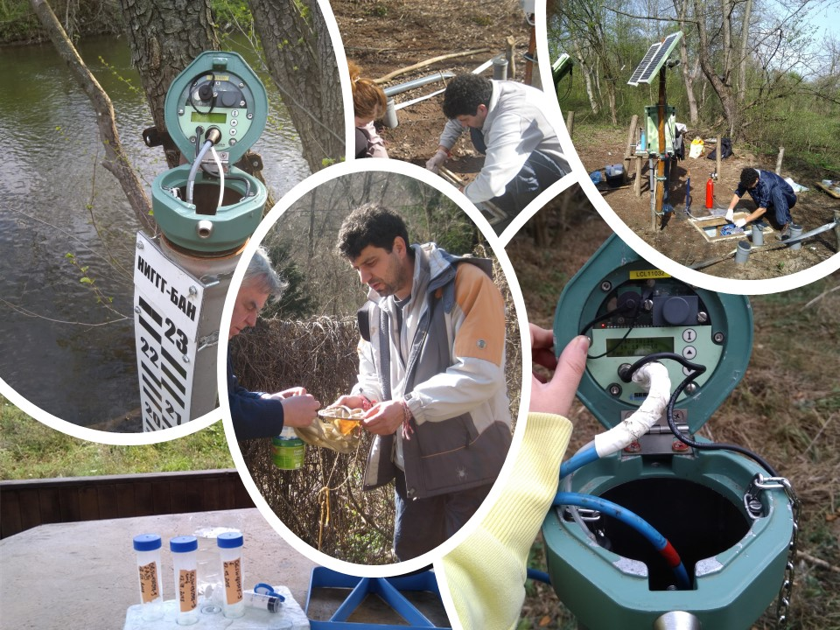
Monitoring of waters and soils in the Ogosta river catchment

