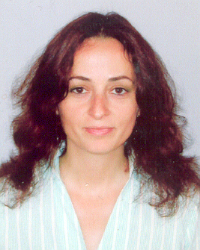 | Ralitza Djubrailova  PhD Student  Tel.: +3592 979 6309  Е-mail: ralica_djubrailova@yahoo.com  Research interests (key words):  history, international relations, geopolitics, diplomacy, world order after Cold war, “frozen conflicts”, post-soviet area, Southeastern Europe, energy projects.  Education:  2010 – National Institute of Geophysics, Geodesy and Geography, BAS, PhD Student.  1999-2001 Sofia University “St. Kliment Ohrdski”, Faculty of Philosophy, MA in European Integration.  1994 – 1999 Sofia University “St. Kliment Ohrdski”, Faculty of Law, MA in International Relations.  Professional experience:  01/2011 – present Embassy of the Republic of Bulgaria in Helsinki, Chargé d’affaires a.i., First Secretary.  01/2009 – 2011 MFA, “European Countries” Directorate, Second Secretary, bilateral diplomacy, BENELUX desk officer.  2006 – 2008 Embassy of the Republic of Bulgaria in Moscow, Second Secretary at the Political Section, multilateral diplomacy.  2005 – 2006 MFA, “Europe III” Directorate /Russian Federation and CIS/, Third Secretary, multilateral diplomacy.  2003 – 2005 MFA, “OSCE Chairmanship” Directorate, Attaché, multilateral diplomacy.  2002 – 2003 MFA, Political cabinet of the Minister of Foreign Affairs, Expert, information and analysis responsibilities.  1999 – 2002 Council of Ministers, Protocol Department, Expert.  March 2005 Representative of the OSCE Chair to the Troika Meeting in Tajikistan.  December 2004 OSCE observer to the re-vote of the second tour of Ukraine’s presidential election in Crimea peninsula, Yevpatoria.  April-September 2004 Member of three OSCE Chair Special Envoy delegations to Moldova and to Transnistria “frozen conflict”.  Selected Publications (last 5 years):  Bulgaria and its Role to the Realization of the European Security and Defense Policy, edited by Peace, Stability and Prosperity Foundation, 2005.  The EU and the OSCE Countries: State of Affairs and Development of the Relationships in the Security Field and the Enforcement of the Democratic Values and Traditions”. The Role of Bulgaria., edition in the framework of the Communication Strategy for the accession of Bulgaria to the EU, 2005.  “Alma Stepmother” /as opposite to Alma Mater/, Capital Weekly, 23/08/2003.  Bulgaria’s Problems and Achievements in the Unemployment Social Protection and Employment Encouragement with a view to the Implementation of the “Acquis Communautaire”, edition of Berlin Free University in cooperation with Institute for Political and Legal Researches, 2000.

