Velimira Stoyanova
Tel.: 0889885934
e-mail: velimira_asenova@abv.bg

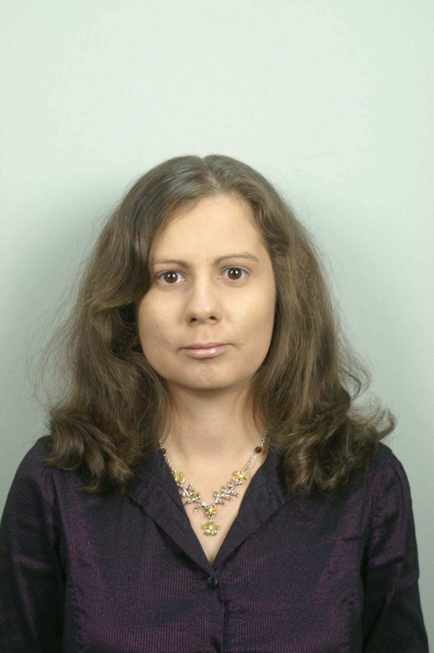
Research interest: landscape classification and structure

Background:
Education: Master degree: Physical geography and landscape ecology; Regional development and management

Professional experience:

Recent projects (last 5 years):

Selected Publications (last 5 years):
Stoyanova V., High waves at the Danube river catchment. International scientific conference dedicated to Earth Day - “global changes and problems: theory and practice” – 20 – 22 April 2007, Sofia, Bulgaria;
Stoyanova V., Hidro-ecological problems at the Maritsa river catchment between Pazardzhik and Plovdiv. International scientific conference dedicated to Earth Day - “global changes: vulnerability, mitigation and adaptation” – 17 – 18 April 2008, Sofia, Bulgaria;

