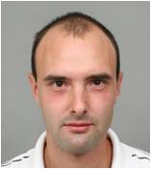 | Stefan Genchev  Geographer  Tel.: +3592 979 63 09  Е-mail: st.genchev85@abv.bg, stef4_123@abv.bg  Research interests (key words):  GIS, Geoeconomics  Education:  BA, Geography, Sofia University, 2008  Professional experience:  2010 – present National Institute for Geophysics, Geodesy, and Geography, BAS.  Recent projects (last 5 years):  Geo-Spatial Investigation and Assessment of the Natural Hazards Risks in Areas of High Concentration of Essential Archeological Monuments (member of the team)  Selected Publications (last 5 years):  Petrov P., G. Jelezov, St.Genchev. 2010. Danube recreation and tourist area. Problems and perspectives. In Proceedings of “Geography and Regional Development” International Scientific Conference, Sofia, 14-16 October, pp. 299-305.

