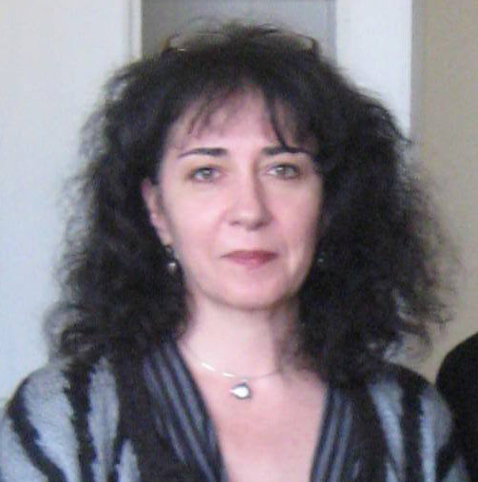 | Yulia Krumova  Assist. Prof.  Tel.: +3592 979 3371  Е-mail: jkrumova@bas.bg; jkrumova@gmail.com  Research interests (key words):  Thematic mapping, GIS based Cartography, Cartography of Natural hazards, Map Design, Graphic Semiology;  Education:  1985 – St. Climent Ohridski Sofia University, Department of Geology and Geography – Master’s degree in Geography, First major: Geomorphology and Cartography, Second major: French Philology;  Professional experience:  2010 - 2011 – Assistant Professor (Research Assoc. I degree) National Institute of Geophysics, Geodesy and Geography, Bulgarian Academy of Sciences (BAS);  2003 - 2010 – Research Assoc. I degree in Institute of Geography, (BAS);  2000 - 2003 – Research Assoc. II degree in Institute of Geography, (BAS);  1996 - 2000 – Research Assoc. III degree in Institute of Geography, (BAS);  1985 - 1996 – geographer researcher in Institute of Geography, (BAS).  Recent projects (last 5 years):  GIS Database Creation of Natural and Culture Heritage Objects in Danube Plain. Project Leader: Assist. Prof. Y. Kroumova, NIGGG – BAS, 2010-2013;  Remote (Aerospace) and Ground Bazed Methods for Investigation of Anormal Natural and Anthropogenic Processes and Phenomena. Project Leader: Prof. G. Mardirossian, DSc – Space and Solar-Terrestrial Research Institute, BAS, 2010-2013;  Formation of Highly Qualified Young Researchers in Information Technologies for Optimization, Pattern Recognition and Decision Support Systems. Project Leader: Assoc. prof. I. Mustakerov, PhD, NIGGG – BAS - Assoc. prof. Dilyana Stefanova, 2009-2011;  SCHEMA (Scenarios for Hazard-Induced Emergencies Management) – 6th EU Framework Programe. Project Leader: Assoc. Prof. B. Rangelov, Geophysical Institute – BAS, 2007-2010;  Natural and Culture Heritage of Bulgaria – Basis for the Functioning of Local, Regional and National Tourist Product. Project Leader: Assoc. Prof. P. Petrov, Institute of Geography – BAS, 2005-2010;  Bulgaria – Geographic Atlas. Project Leader: Assoc. Prof. I. Kopralev, Institute of Geography – BAS, 2006-2009;  Methods and Means for Study of Anomalous Processes of Natural and Anthropogenic Origin: Project Leader: Prof. G. Mardirossian, DSc – Space Research Institute - BAS, 2006-2009;  Implementation of the “ Kineros” Model for Estimation of the Flood Prone Territories of the Malki Iskar basin. Project Leader: Assoc. Prof. M. Nikolova, Institute of Geography – BAS, 2007-2008;  Investigation of Protected Mountain Areas of the Category "Nature Park" in Romania and Bulgaria to Harmonize their Management in Accordance with the European standards. Project Leader: Assoc. Prof. M. Nikolova, Institute of Geography – BAS, 2005-2008;  Map of Geological Hazards in the Balkans. Project Leader Assoc. Prof. B. Rangelov, Geophysical Institute – BAS, 2006-2007;  Hazardous Natural, Social and Technogenic Processes and Phenomena in Eastern Stara Planina mountain. Assoc. Prof. M. Nikolova, Institute of Geography – BAS, 2003-2007.  Selected Publications (last 5 years):  B. Ranguelov, G. Mardirossian, G. Jelev, S. Scheer, Y. Krumova 2010. Atlas of Tsunami Risk Maps Creation. Sixth Scientific Conference with international participation SPACE, ECOLOGY, SAFETY (SES, 2010), BAS – Space and Solar-terrestrial Research Institute, Bulgarian astronautical society, Sofia, 02-04 November.  Krumova,Y., B. Ranguelov, G. Mardirossian. 2010. Risk maps preparation and atlas compilation about Bulgarian Black Sea tsunami zones. Межд. конф. География и регионално развитие”, НИГГГ, София, 14-16 октомври, 465-472.  Krumova,Y., 2010. Aspects of Thematic Map Design of „Bulgaria – Geographic Atlas”. Int. Conf. Geography and Regional Development, NIGGG, Sofia, 14-16 October, 492-502.  Nikolova, M., S. Nedkov, V. Nikolov, I. Zuzdrov, M. Genev, T. Kotsev, R.Vatseva and Y. Krumova. 2009. Implementation of the “ Kineros” model for estimation of the flood prone territories of the Malki Iskar basin – “Information and Security”, Information & Security: An International Journal, Volume 24, 76-88.  Kroumova, Y. 2009. Mountains and Mountain Regions in Bulgaria. In: Identifying the Research Basis for Sustainable Development of the Mountain Regions in Southeastern Europe. 24 – 26 April, Borovets, Bulgaria, 33-41.  *** Bulgaria – Geographic Atlas (bilingual edition). TANGRA TanNakRa, Sofia, 2010. Cartography and Map Design: Y. Kroumova.

