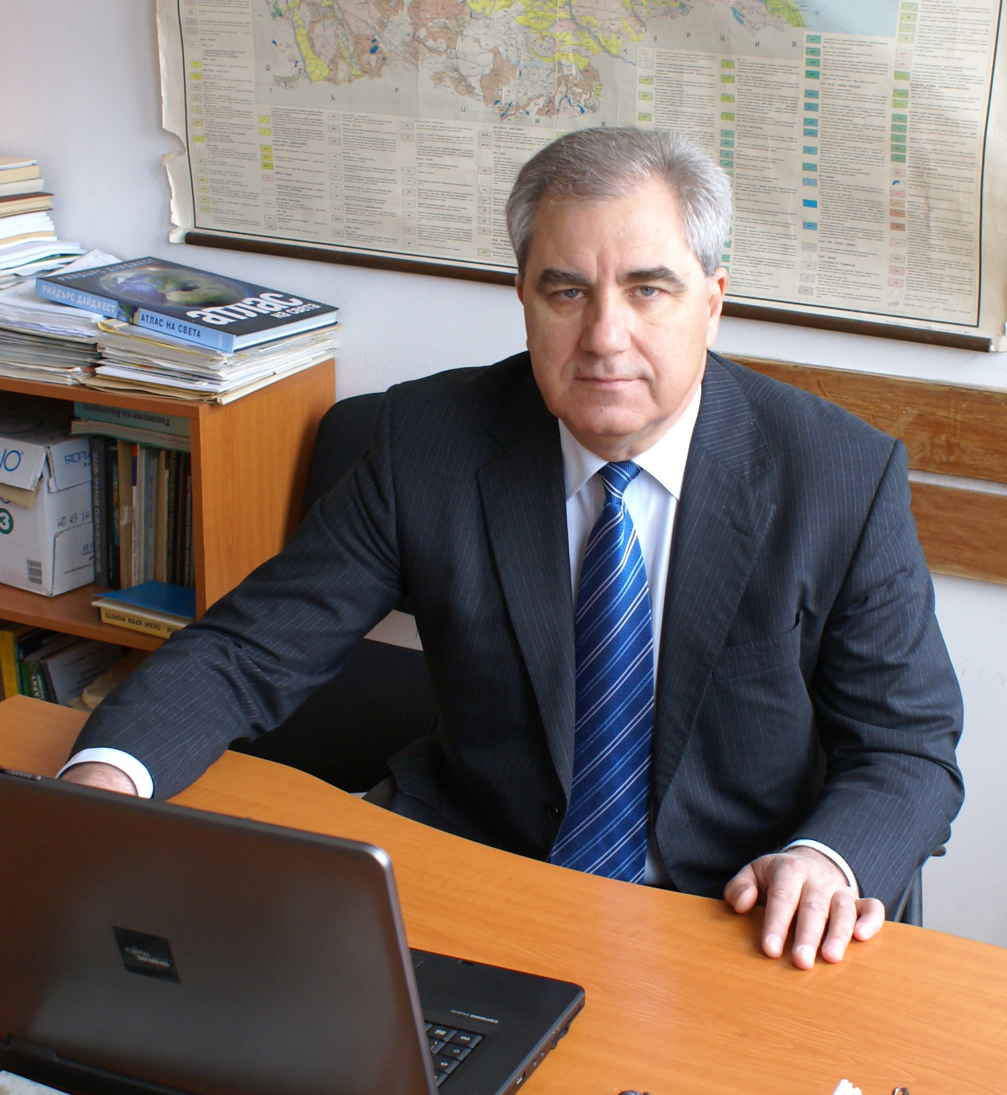 | Prof. Georgi Alexiev, DSc  Tel.: +3592 – 979 – 33- 67  Е-mail: Tsvetkov_g@abv.bg  Research interests (key words):  geology, morphotectonics, neotectonics, Quaternary tectonics, geodynamics, palaeogeography, environmental protection, hazardour geomorphological processes.  Education:  2010 – Professor;  2009 - Doktor of Sciences “Morphotektonics of the Balkan peninsula”;  1996 - Associate Professor for his contributions to geomorphology and  palaeogeography;  1994 - Ph.D. degree for his dissertation "Geomorphological Characteristics of Block-Type Gravity Deformations;  1978 - Geography with qualifications as a physical geographer – geomorphologist and cartographer, graduated from the Sofia University "St. Kl. Ohridski"", Dept. of Geology and Geography, speciality ";  Professional experience:  2010 – present Professor, National Institute for Geophysics, Geodesy, and Geography, BAS; BAS.  2000-2008 – Director of the Institute of Geography, BAS;  Recent projects (last 5 years):  Географски терминологичен речник. Project leader. 2005-2008.  Земеползване и карстогенезис в централна и Югоизточна Европа. ЕБР със Силезийския у-тет в Катовице, Полша, Project leader. 2005-2008.  Транскрибиране на указателя на географските понятия на български език на Световния географски атлас; Договорна задача с “Ридъръс Дайджест”. Project leader. 2006-2007.  ”Balkan Geohazard Map and Assessment” OPP-024 of United States Civilian Research & Development Foundation (CRDF), Project leader from Bulgaria. 2007-2008.  “Indentification and collection of implementation – oriented technological and organizational practices and measures for the reduction of natural disaster risk”. JRS-Ispra, Italia, Project manager. 2007.  Selected Publications (last 5 years):  Rangelov, B. D.Gospodinov, S.Sheer, E.Krausman, G.Alexiev, M. Nikolova., 2007. Methodology of creation the tenplates for an EU tender to BAS., SENS’07, Varna, 27-29 June, 2007. pp 88-93.  Rangelov, B., Dimitrova, S., Gospodinov D.,Alexiev, G.,Mardirosian, G.,2007. Natural hazards and the environmwntally disturbed region of the Maritza – Iztok open coal mine, Bulgaria.,Proc. Intl. Conf., “Protection of the natural disasters disturbed regions, 15-22.  Rangelov, B., Alexiev, G., Gospodinov D.,2009. Natural Hazards Cartography in Bulgaria – a European perspective. Proc. 19 th Intl. Symp.Geodesy 09., Sofia,5-6 Nov. 2009, pp. 260-266, ISBN: 978-80-87159-07-1.”.,Strbske pleso, 18-22 November, Slovakia. pp. 15-22.  Muco,B., Alexiev,G. Aliaj, S, Elezi, Z, Gresu, B, Mandrescu, N, Milutinovic, Z, Radulian, M, . Rangelov, B., Shkupi, D., 2008. Geohazards map and assessment of some Balkan countries ., Abst. 31st Gen. Ass. ESC., 7-12 Sept., Hersonissos, Greece, pp. 372 ( on CD).  Rangelov, B., Alexiev, G., Gospodinov D., Sheer, S., 2009, Natural Hazards and Preventive Measures in Bulgaria., Intl. Conf. SUB, V.Tarnovo, 17 Oct.  Alexiev, G.2009. ”Моrphotektonics of the Balkan peninsula”, Sofia, BAS, pp. 1-71.  Алексиев, Г., 2008. Оценка на опасността от наводнения. Списание на БАН. Кн. 6, 44-51.  Генев, М., Г.Алексиев, 2010. Някои концепции относно изменението на климата. Сб.”Междукултурен диалог и образование на Балканите и Източна Европа”. Изд.”Ивис”, В. Търново, 249-270.  Алексиев, Г. 2010. Неоалпийски ендогенен модел на морфогенеза на Балканския полуостров. Сб.”Междукултурен диалог и образование на Балканите и Източна Европа”. Изд.”Ивис”, В. Търново, 110-146.

