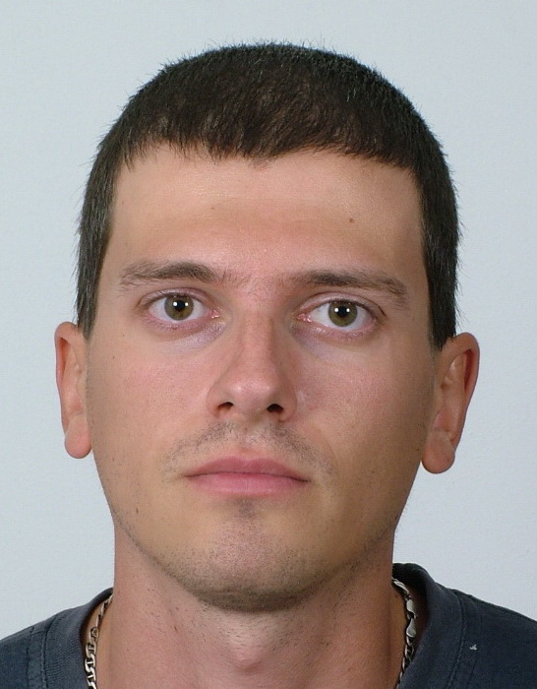 | Evgeni Baltakov  PhD Student  Tel.: +3592 979 6309  Е-mail: egb@mail.bg  Research interests (key words):  Geomorphology, Paleogeography, Karst  Education:  2010 - National Institute of Geophysics, Geodesy and Geography, BAS, PhD Student  2009 – MA - “St. Kliment Ohridski” Sofia University, Geology and Geography Faculty.  Professional experience:  04-08/2009 – School teacher  Recent projects (last 5 years):  „Working out an experimental model for complex monitoring of protected karst territories aiming at their sustainable development, management and development”, Project Leader Assoc. Prof. M. Yordanova, 2009-2011.  “Water resources management of trance-border river basins between Republic of Bulgaria and Republic of Serbia”, Project Leader Assoc. Prof. N. Hristova, 2010.  “Formation of Highly Qualified Young Researchers in Information Technologies for Optimization, Pattern Recognition and Decision Support Systems”. Contract with the Ministry of Education, Youth and Science: BG051PO001-3.3.04/40/28.08.2009, Project Leader Assoc. Prof. Dr. Ivan Mustakerov, 2009-2011.

